- Bluebook Page162 August 2019 variant one examination:

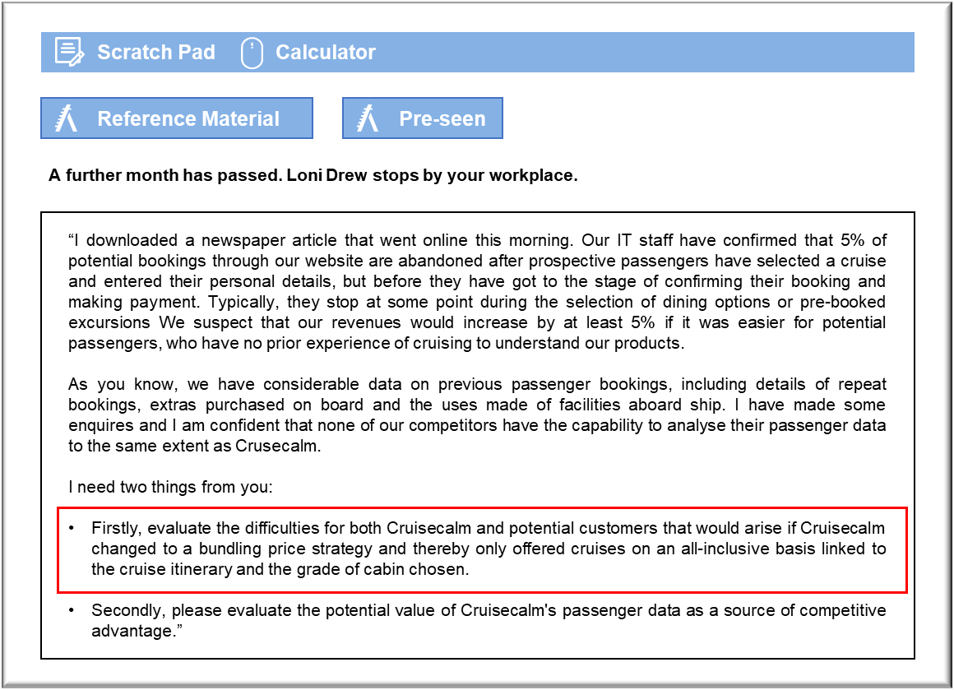

MANAGEMENT CASE STUDY AUGUST 2019 EXAM ANSWERS

Variant1 Task3
These answers have been provided by CIMA for information purposes only. The answers created are indicative of a response that could be given by a good candidate. They are not to be considered exhaustive, and other appropriate relevant responses would receive credit.

CIMA will not accept challenges to these answers on the basis of academic judgement.

Requirement 1: Bundling products
The most immediate problem is that some passengers will be put off by being confronted by the total cost of the cruise, inclusive of excursions and upgrades. At present, Cruisecalm’s website appears to focus on a relatively low “basic” cost for a cruise, in the hope of attracting passengers.
Passengers can then add to that to tailor their cruises to match their personal budgets, allowing for any upgrades that they wish to purchase.
Removing the flexibility associated with tailoring cruise packages could deter experienced
passengers who know what they require and are unwilling to pay more for a package that
includes features that they do not wish to pay for. That suggests that Cruisecalm would have to offer the ability to modify the bundles, which could add to the confusion. It might be possible to overcome this by having two links on the bookings home page, one offering a simple bundle and the other offering tailor-made packages.
Bundles could cost Cruisecalm revenue if the included upgrades are relatively modest. The whole point of this process is to simplify booking and so passengers may select the basic package without further exploring the additional upgrades that could be purchased. Those passengers may then be dissatisfied with their cruise if they find themselves making significant additional purchases during their holiday.
Bundles are often associated with discounts, with the bundle being sold for less than the total cost of the individual parts of the offer. If Cruisecalm discounts its prices then it may confuse some more experienced passengers who realise that tailoring a cruise could prove more expensive than buying a bundle. Again, it could prove cheaper to lose some bookings in order to charge the full price for the basic cruise plus optional extras.
Requirement 2: Competitive advantage
Cruisecalm’s passenger data could be a major resource in encouraging passengers to make
repeat bookings, rather than, having them book with other cruise lines or on other types of
holiday. For example, Cruisecalm knows when passengers booked their most recent cruise, so they could send an email at that same time of year, or a little earlier. That should hopefully
coincide with the time that passengers book their annual holiday. The reminder could be
personalised to refer to the name of the ship and the route booked last year and recommending similar cruises on which there is availability.
Passenger feedback could also be used to inform regular updates that might be put on a blog, with links emailed regularly to passengers. The updates could be written in a positive manner, but could make subtle references to improvements that have been made. If, for example, the entertainment was not well received on a particular ship then the blog or messages could introduce the new acts that have been booked for the forthcoming season.
The fact that some bookings are made through travel agents could reduce Cruisecalm’s ability to capitalise on its ability to contact previous passengers. The travel agents will not release confidential details to other cruise lines, but they will be keen to sell holidays to past customers, including those who have previously sailed with Cruisecalm. They might, for example, email former passengers with details of special offers on cruises offered by are Wavelyne or Saildine.
The nature of the cruise industry suggests that cruise lines need to be innovative and forward looking in order to retain passengers and the analysis of passenger data may be essentially backward looking. For example, competing cruise lines might add new features to their ships that attract passengers away from Cruisecalm. Cruisecalm could attempt to pre-empt that by adding features to its ships, but passenger data might not help them with that. Passengers may not be particularly good at suggesting such features because they may not appreciate what is actually possible.

